Namespaces in General
Namespaces allow you to group related classes, interfaces, structs, enums, and delegates into a single logical unit.

Namespaces also help you avoid naming conflict issues.

Think of a Namespace as a container. Much like a folder on your hard drive. These containers contain classes for you to work with and other Namespaces/containers. In the .NET Framework there is a top-level Namespace called System. In System you will find you will find several other Namespaces e.g., Windows. Look in Windows and you will see classes to use and more Namespaces. To get to the Button Class you need to reference the System.Windows.Forms Namespace.
The diagram below attempts to describe the Namespace structure required to expose the Button Class.
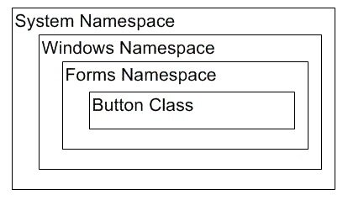

EmpowerWin Solution Hierarchical Structure

Folders, Sub-Folders and Projects start the hierarchical organization of the EmpowerWin Solution.
Projects further organize classes using Folders and Sub-folders.

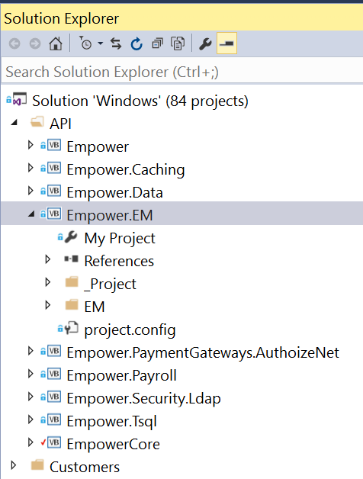

Above, the API folder contains nine projects. Each of the project’s Root Namespace is Empower.

The Empower.EM project contains an EM Folder. And under the EM folder are multiple sub-folders. The folders and sub-folders within a project DO NOT affect Namespaces .They are defined to make navigating the solution easier, much like folders and sub-folders in Windows File Explorer.

Namespaces in EmpowerNet

The base namespace in EmpowerNet is EMPOWER.

There are multiple Root Namespaces in the EmpowerWin Solution as follows:

Folder | Sub Folder | Project | Root Namespace in Projects
API |  | Empower | Empower
 |  | Empower.Caching | Empower
 |  | Empower.Data | Empower
 |  | Empower.EM | Empower
 |  | Empower.Payroll | Empower
 |  | Empower.Security.LDAP | Empower.Security
 |  | Empower.TSQL | Empower
 |  | EmpowerCORE | Empower
Database |  | Empower.Conversion | Empower.Conversion
 |  | Empower.Maintenance | Empower.Maintenance
Partners | Monitor | Empower.Monitor | Empower
 |  | Empower.Windows.Monitor | Empower.Windows.Monitor
Windows |  | Empower.Windows | Empower.Windows
 |  | Empower.Windows.Controls | Empower.Windows
 |  | EmpowerWIN | Empower.Windows

Assigning Namespaces in EmpowerWin

Each Project in EmpowerNet solutions assigns the Root Namespace Namespace in the Project’s properties.

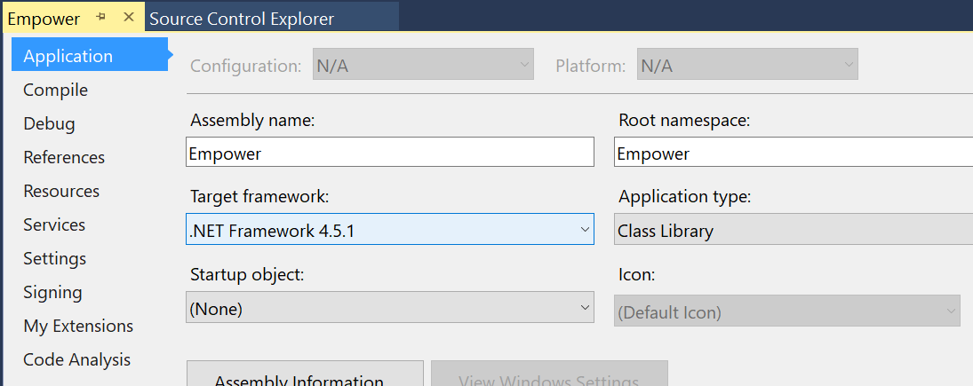

Extensions of the base Namespace are defined in classes, interfaces, etc. using the Namespace statement at the beginning of a class.

For example, the AccountBegin column class in the Empower project begins as:
Namespace EM.Columns
Public Class AccountBeginColumn
…
…
End Class
End Namespace

Thus, the AccountBegin class’s fully qualified name is Empower.EM.Columns.AccountBegin.

While scripting within the EM.Columns Namespace you may refer to the class as
AccountBegin.

Outside of the EM.Columns Namespace you refer to the class as
Empower.EM.Columns.AccountBegin
Which can be abbreviated to EM.Columns.AccountBegin if the Projects Root Namespace is Empower.

EmpowerWin’s Extended Namespaces

The classes (from now on classes refers to classes, interfaces, structs, enums, and delegates) in the EmpowerNet projects all contain a Namespace statement which is used to extend the project’s Root Namespace.

Below is a partial list of extended Root Namespaces

Empower.EM
Empower.EDI
Empower.IO
Empower.Payroll
Empower.Reporting

Many extended Root Namespaces are further extended to group classes. Examples are Empower.EM.Documents and Empower.EM.Entities.

EmpowerWin’s Customer Projects Namespaces

The Empower.EM (extended Namespace) and Empower.Windows (Root Namespace) have extra importance as they are used to differentiate classes owned by Empower and classes owned by Customers.

When a customer modification requires a new, or modified class, the new/modified classes are contained in one of two customer specific Projects:

<customer name>.Empower
<customer name>.Empower.Windows.

The above Projects live in the primary folder, Customers, and a sub-folder name <customer name>.

In the <customer name>.Empower project each customer class is contained within customer specific extended Namespaces:
Empower.<customer name>.<standard Namespace Extension>

For example, a custom Column for customer Barnes would be in the Barnes.Empower project , which has a root namespace of Empower, and assigned a customer namespace, Empower.Barnes.Columns, which is scripted as the first line in the custom customer class as:

Namespace Barnes.Columns
… class script
…
End Namespace

The fully qualified namespace of Empower.Barnes.Columns is derived from the Root Namespace of the Barnes.Empower project (Empower) and the namespace extension of Barnes.Columns.
A slightly different Namespace convention is used for modified or new Windows Form class for customers. A new/modified windows form for Barnes would be in the Barnes.Empower.Windows project , which has a root namespace of Empower.Windows.Barnes and assigned a customer namespace, Empower.Windows.Barnes.UI.Forms.Processes, which is scripted as the first line in the custom customer forms class as:

Namespace UI.Forms.Processes
…class script
End Namespace

The fully qualified namespace of Empower.Windows.Barnes.UI.Forms.Processes is derived from the Root Namespace of the Barnes.Empower.Windows project (Empower.Windows.Barnes) and the namespace extension of UI.Forms.Processes.

In summary, namespaces in our customer projects are defined differently for Windows Forms classes and non-Windows Form classes.

For non-Windows Form Classes
- Create a customer project named <customer name>.EMPOWER. Set the root namespace to EMPOWER
- Create an extended Namespace using the Namespace statement in the class of <customer name>.standard namespace extension>
- The above USUALLY replaces EM in the standard Namespace with the <customer name>. Examples being:

Empower.EM.Columns | Empower.Barnes.Columns
Namespace.EM.Documents | Empower.Barnes.Documents

For Windows Form Classes
- Create a customer project named <customer name>.Empower.Windows. Set the Root Namespace to Empower.Windows.<customer name>
- Create an extended Namespace using the Namespace statement in the Windows Form class of Empower.Windows.<customer name>.standard namespace extension>
- The above means we DO NOT CHANGE the standard Namespace of the copied Form. Examples being:

Empower.Windows.UI.Forms.Processes | Empower.Windows.Barnes.UI.Forms.Processes

Customer Class Names

Since the fully extended class name is a concatenation of the Namespace and the class name, even though the customer Namespaces are different than the Empower Namespaces:

we prefix the <customer name> to the class name when the class name is a modified standard class, and the class name is a key column of the database table or has different dropdown. powersearch/validations.

We do not prefix the class name if the class name is not used in our standard classes. The most common example being a column that is in a custom table that is never going to be used in our standard classes.

Example classes are:
Empower.Medway.Columns.MedwayQualityIssue ( standard column quality issue)
Empower.Medway.Columns.CorrectiveAction (no standard column with this name)

The best practice is to always use the <customer.name> as a prefix to the class, but this is subject to discussion as using the customer’s name can make the class name verbose.

